Vanier College

Computer Science Department

Web Services 420-551-VA

Section 00001

**Project Proposal**

Emmy Ea

Jiamin Yuan

**TABLE OF CONTENTS**

PROPOSAL IDEA 3

ERD 3

ERD RELATIONSHIPS 3

RESOURCES 4

RECORDS 4

ENTRIES 5

PETS 5

APPEARANCES 6

CATEGORIES 7

RELATIONSHIPS 7

HTTP RESPONSE STATUS CODES 8

PAGINATION 8

## **PROPOSAL IDEA**

Our RESTful Web service shows animal records at shelters. It will display animals that are lost, found or adoptable. Our web service will allow sorting animals by category.

Our media type is of JSON format.

## **ERD**

<https://drive.google.com/file/d/13N6eAcmQmnF-kng8evjTvDArNpGCtJM4/view?usp=sharing>

**GITHUB REPOSITORY**

<https://github.com/JiaminYuan/WebServices_FinalProject.git>

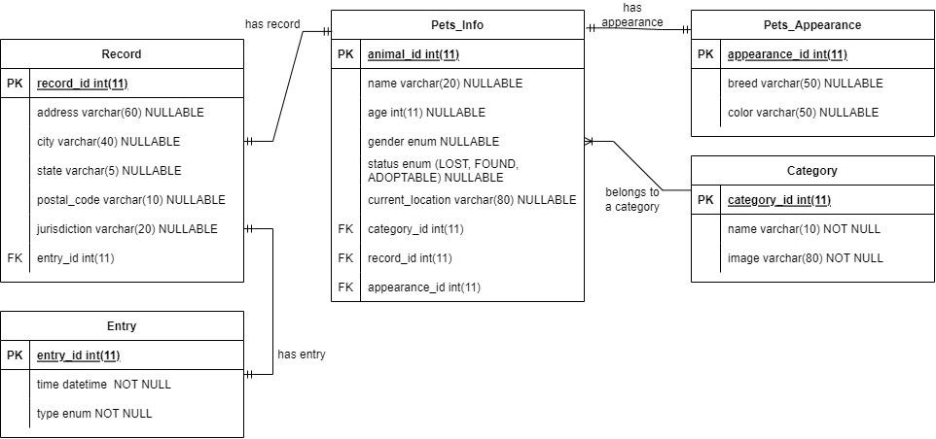

## **ERD RELATIONSHIPS**

Pets_info - Pets_Appearance (one to one):

Animals have one appearance. Each animal has a unique appearance.

Pets_info - Record (one to one):

Animals have one record. A record belongs to one animal.

Record - Entry (one to one):

A record has one entry and an entry belongs to a record.

Pets_info - Category (many to one):

An animal belongs to one category. A category has more than one animal.

# **RESOURCES**

|  |  |  |  |
| --- | --- | --- | --- |
| Name | URI | HTTP Methods | Description |
| records | /records | GET, POST, PATCH, DELETE | A list of pets’ current information |
| entries | /entries | GET, POST, PATCH, DELETE | A list of pets’ entry |
| pets | /pets | GET, POST, PATCH, DELETE | A list of registered pets |
| appearances | /appearance | GET, POST, PATCH, DELETE | A list of pets’ appearances |
| categories | /categories | GET, POST, PATCH, DELETE | A list of filtered pets |

# **RECORDS**

**Subtype of Records:**

|  |  |  |
| --- | --- | --- |
| Name | Type | Description |
| record_id | int | The record id of a pet |
| address | string | The current address of a pet |
| city | string | The current city of a pet |
| state | string | The current state of a pet |
| postal_code | string | The current postal_code of a pet |
| jurisdiction | string | The current jurisdiction of a pet |
| entry_id | int | The entry id of a pet (FK) |

**Filtering Records:**

|  |  |  |  |
| --- | --- | --- | --- |
| Parameters | URI | Type | Result |
| city | /record/{city} | String | Pets residing within the given city are included in the response |
| state | /record/{state} | String | Pets residing within the given state are included in the response |
| postal_code | /record/{postal_code} | String | Pets residing within the given postal code are included in the response |
| jurisdiction | /record/{jurisdiction} | String | Pets residing within the given jurisdiction are included in the response |

# **ENTRIES**

**Subtype of Entries:**

|  |  |  |
| --- | --- | --- |
| Name | Type | Description |
| entry_id | int | The entry id |
| time | string | The entry time of a registered pet |
| type | string | The type of entry of a pet |

**Filtering Entries:**

|  |  |  |  |
| --- | --- | --- | --- |
| Parameters | URI | Type | Result |
| type | /entries/{type} | String | Entries of given type are included in the response |

# **PETS**

**Subtype of Pets:**

|  |  |  |
| --- | --- | --- |
| Name | Type | Description |
| animal_id | int | The animal id of a pet |
| name | string | The name of a pet |
| age | string | The age of a pet |
| status | string | The status of a pet (lost, found or adoptable) |
| current_location | string | The current location of a pet |
| category_id | int | The category id of a pet |
| record_id | int | The record id of a pet |
| appearance_id | int | The appearance id of a pet |

**Filtering Pets:**

|  |  |  |  |
| --- | --- | --- | --- |
| Parameters | URI | Type | Result |
| name | /pets/{name} | String | Pets with the given name are included in the response |
| age | /pets/{age} | String | Pets with the given age are included in the response |
| gender | /pets/{gender} | String | Pets with the given gender are included in the response |
| status | /pets/{status} | String | Pets with the given status are included in the response |
| category | /pets/{category} | String | Pets with the given category are included in the response |

# **APPEARANCES**

**Subtypes of Appearances:**

|  |  |  |
| --- | --- | --- |
| Name | Type | Description |
| appearance_id | int | The appearance id of a pet |
| breed | string | The breed of a pet |
| colour | string | The colour of a pet |

**Filtering Appearances:**

|  |  |  |  |
| --- | --- | --- | --- |
| Parameters | URI | Type | Result |
| breed | /appearances/{breed} | String | Pets with the given breed are included in the response |
| colour | /appearances/{colour} | String | Pets with the given colour are included in the response |

# **CATEGORIES**

**Subtypes of Categories:**

|  |  |  |
| --- | --- | --- |
| Name | Type | Description |
| category_id | int | The category id of a pet |
| name | string | The category name of a pet |
| image | string | The image of a pet |

**Filtering Categories:**

|  |  |  |  |
| --- | --- | --- | --- |
| Parameters | URI | Type | Result |
| name | /categories/{name} | String | Pets with the given category are included in the response |

# **RELATIONSHIPS**

|  |  |
| --- | --- |
| URI | Description |
| /records/{entry_id} | A specific entry for a record |
| /pets/{category_id} | A specific category for a pet |
| /pets/{record_id} | A specific record for a pet |
| /pets/{appearance_id} | A specific appearance for a pet |

## **HTTP RESPONSE STATUS CODES**

GET:

* 200: Ok
* 404: Resource not found

POST//PUT:

* 201: Created
* 403: Forbidden
* 422: Validation Fail

PATCH:

* 200: Ok
* 404: Resource not found
* 422: Validation Fail

DELETE:

* 202: Accepted
* 204: No Content

# **PAGINATION**

|  |  |
| --- | --- |
| URI | Headers/Parameter |
| /records | ?page={page_number}&pageSize={page_size} |
| /entries | ?page={page_number}&pageSize={page_size} |
| /pets | ?page={page_number}&pageSize={page_size} |
| /appearance | ?page={page_number}&pageSize={page_size} |
| /categories | ?page={page_number}&pageSize={page_size} |